241901005

EX. NO: 4 SQL INJECTION LAB

Aim:
To perform SQL Injection Lab in TryHackMe platform to exploit various vulnerabilities.

ALGORITHM:
- Access the SQL Injection Lab in TryHackMe platform using the link- https://tryhackme.com/r/room/sqlilab
- Click Start AttackBox to run the instance of Kalilinux distribution.
- Perform SQL injection attacks on the following-
  - Input Box Non-String
  - Input Box String
  - URL Injection
  - POST Injection
  - UPDATE Statement
- Perform broken authentication of login forms with blind SQL injection to extract admin, password
- Perform UNION-based SQL injection and exploit the vulnerable book search function to retrieve the flag

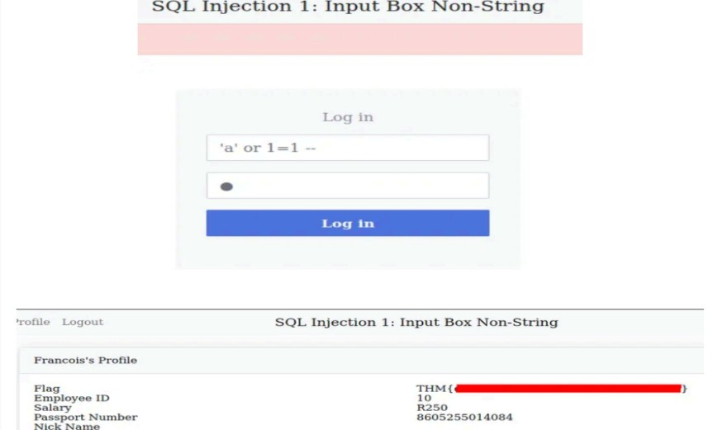
OUTPUT:

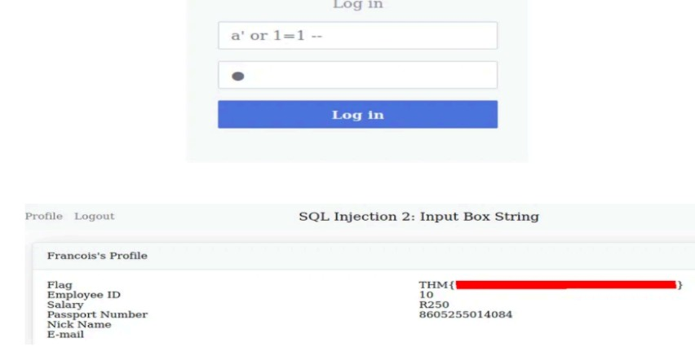
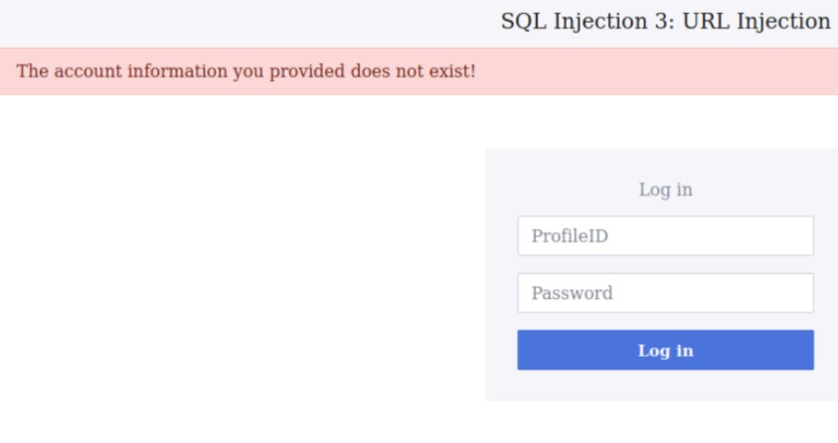
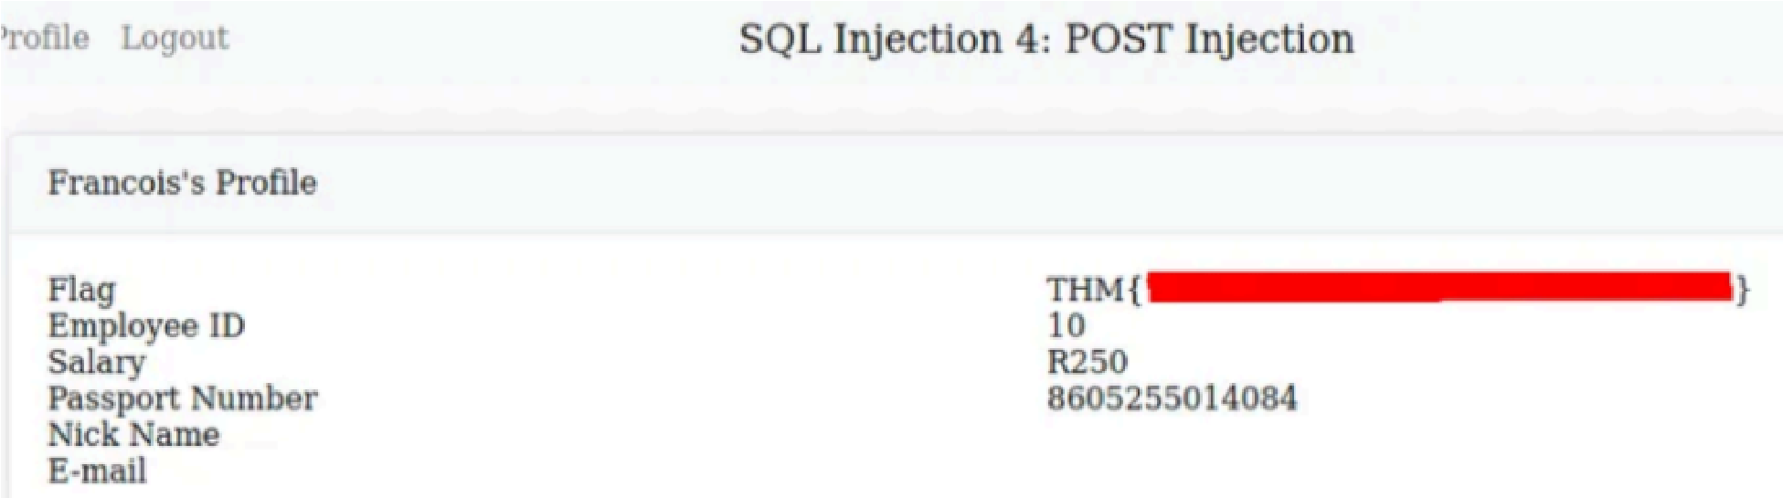

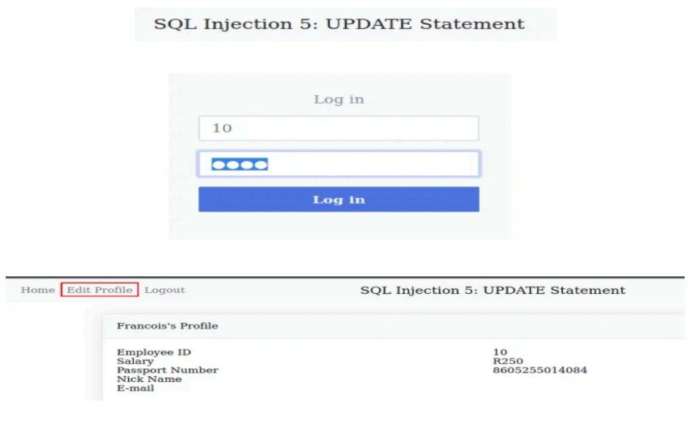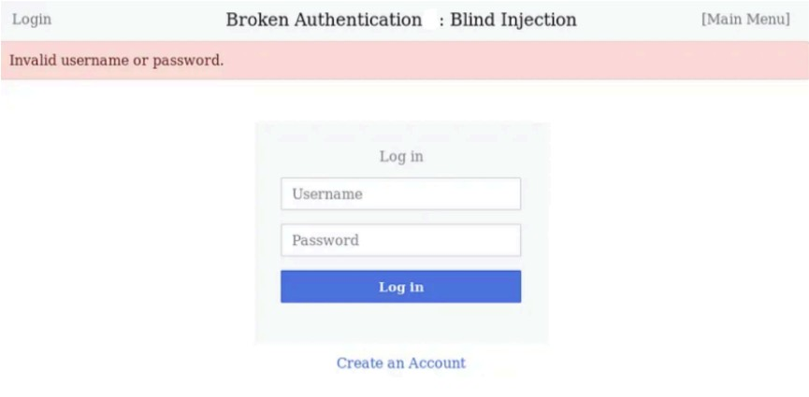

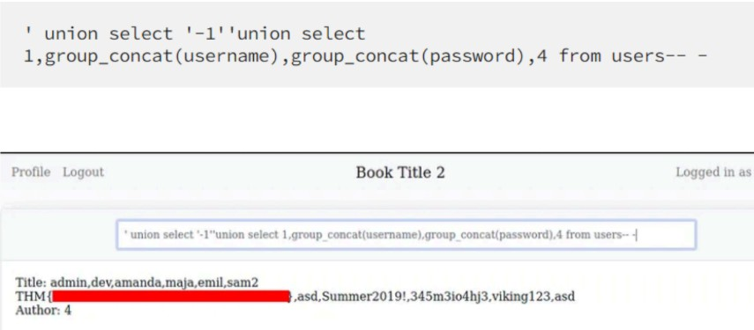

RESULT:
Thus, the various exploits were performed using SQL Injection Attack.

